**class Car{**

**private int year;**

**private String make;**

**private double speed;**

**Car( int year,String make, double speed){**

**this.year=year;**

**this.make=make;**

**this.speed=speed;**

**}**

**int getYear(){**

**return year;**

**}**

**String getMake(){**

**return this.make;**

**}**

**double getSpedd(){**

**return speed;**

**}**

**void accelerate(){**

**speed=speed+1;**

**}**

**}**

**class RaceTrack{**

**public static void main(String []args){**

**Car c1=new Car(2015,"Duster",60.00);**

**System.out.println("Year of manufacturing is =="+c1.getYear());**

**System.out.println("Name of car is =="+c1.getMake());**

**System.out.println("Speed of car is =="+c1.getSpedd());**

**c1.accelerate();**

**System.out.println("Speed of car after acceleratation is =="+c1.getSpedd());**

**}**

**}**

**class RaceTrack{**

**public static void main(String []args){**

**Car c1=new Car(2015,"Duster",60.00);**

**//Currnt stutus of object**

**System.out.println("MFG Year =="+c1.getYear());**

**System.out.println("Name of car =="+c1.getMake());**

**System.out.println("Speed of car =="+c1.getSpedd());**

**c1.accelerate();**

**System.out.println("Speed of car after acceleratation is =="+c1.getSpedd());**

**}**

**}**

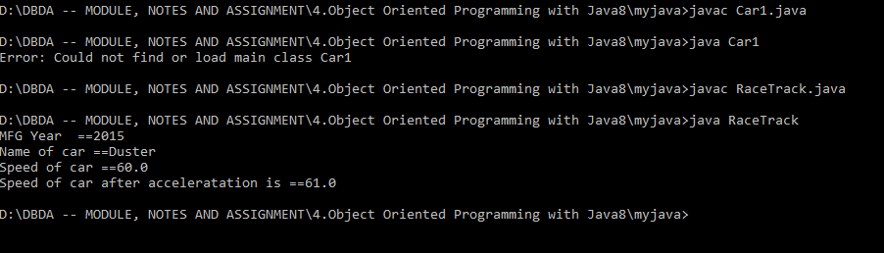

**////////////////////////////////////////////////////////////////////////////////**

**Q2..**

**import java.util.*;**

**class Item{**

**Integer item_id;**

**String item_name;**

**Item(int item_id,String item_name ){**

**this.item_name=item_name;**

**this.item_id=item_id;**

**}**

**Item(){}**

**void setitem_id(int item_id){**

**this.item_id=item_id;**

**}**

**void setitem_name(String item_name){**

**this.item_name=item_name;**

**}**

**public String toString(){**

**return this.item_id+" "+this.item_name;**

**}**

**@Override**

**public boolean equals(Object o){**

**if(o instanceof Item){**

**Item temp= (Item) o;**

**if(this.item_id.equals(temp.item_id) && (this.item_name.equals(temp.item_name) )){**

**return true;**

**}**

**}**

**return false;**

**}**

**@Override**

**public int hashCode(){**

**int prime = 13;**

**int val = 1;**

**val = val*prime + this.item_id.hashCode();**

**val = val*prime + this.item_name.hashCode();**

**return val;**

**}**

**}**

**class namesort implements Comparator<Item>{**

**public int compare(Item I1,Item I2){**

**return I1.item_name.compareTo(I2.item_name);**

**}**

**}**

**class idsort implements Comparator<Item>{**

**public int compare(Item I1,Item I2){**

**return I1.item_id-(I2.item_id);**

**}**

**}**

**class Inventory{**

**static Item I=new Item();**

**static ArrayList<Item> list=new ArrayList<> ();**

**public static void main(String[] args){**

**Scanner sc=new Scanner(System.in);**

**int choice;**

**Item I1=new Item(1,"A");**

**Item I2=new Item(3,"R");**

**Item I3=new Item(2,"Z");**

**Item I4=new Item(4,"H");**

**Item I5=new Item(10,"M");**

**list.add(I1);**

**list.add(I2);**

**list.add(I3);**

**list.add(I4);**

**list.add(I5);**

**do{**

**System.out.println("Enter your choice ==");**

**System.out.println("1) Add Item.\n2) Display complete inventory in sorted order of item names as well as item_id.\n3) Remove Item.\n4) Exit");**

**choice=sc.nextInt();**

**switch(choice){**

**case 1:**

**System.out.println("Enter your details as follows");**

**System.out.println("Enter Item you want add");**

**for(int i=1;i<=1;i++){**

**System.out.println("Enter id of item ");**

**int d=sc.nextInt();**

**I.setitem_id(d);**

**System.out.println("Enter name of item ");**

**sc.nextLine();**

**String ss=sc.nextLine();**

**I.setitem_name(ss);**

**if (!list.contains(I)){**

**list.add(I);}**

**}**

**System.out.println("Added items as follows");**

**System.out.println(list);**

**break;**

**case 2:**

**System.out.println("before sorting");**

**System.out.println(list);**

**System.out.println("Sorting by id");**

**idsort n2=new idsort();**

**Collections.sort(list,n2);**

**System.out.println(list);**

**System.out.println("Sorting by name");**

**namesort n1=new namesort();**

**Collections.sort(list,n1);**

**System.out.println(list);**

**break;**

**case 3:**

**System.out.println("List as follows");**

**System.out.println(list);**

**System.out.println("Enter index od item which you want to remove index start from 0");**

**int re=sc.nextInt();**

**list.remove(re);**

**System.out.println("List after removal");**

**System.out.println(list);**

**break;**

**case 4:**

**System.out.println("Thank you");**

**break;**

**}**

**}while(choice!=4);**

**}**

**}**

**--🡪>**